**France on the Road: A Nation in Motion**

**Insights from Road Accidents (2009–2012)**

**An Evidence-Based Exploration of Risk, Behavior and Road Safety**

MSc Data Science

Data Visualization and Communication  
  
Professors: Dimitris Karlis, Nikos Platis   
  
Giagkos Stylianos | f3352410  
Papadopoulos Ioannis | f3352409  
Vitsentzatos Nikolaos | f3352405

June, 2025

**Contents**

1. Introduction 2

2. Temporal Patterns 2

3. Geographic and Infrastructure Risk 5

4. Demographic Risk Profiles 7

5. Environmental Conditions 9

6. Injury Severity and Health Outcomes 10

7. Behavior and Exposure 13

8. Tableau Dashboard: Interactive Approach 14

9. Conclusions and Policy Recommendations 15

10. Acknowledgments 15

# Introduction

Road accidents represent a critical public safety issue, with significant implications for urban planning, policy development, and public awareness. This report, titled “France on the Road: A Nation in Motion,” leverages data from the French Road Accident Database (BAAC), collected by the French Ministry of the Interior from 2005 to 2023, to analyze injury-causing road accidents in France between 2009 and 2012. The dataset encompasses thousands of incidents annually, capturing details on actors, locations, and risk factors. The primary objective is to derive data-driven insights to inform public safety policies, enhance urban planning, and promote awareness campaigns. This study examines accident patterns through multiple lenses: temporal and seasonal trends, geographic and infrastructure factors, demographic profiles, injury severity, environmental conditions, and behavioral aspects, including safety equipment usage and travel purposes.

The analysis focuses on key dimensions: temporal patterns (day, hour, month, and holidays), geographic and infrastructure characteristics (road types, urban vs. rural settings, and collision types), demographics (age, gender, vehicle type, and travel purpose), and severity outcomes (injury levels and safety behavior impacts). By exploring these factors, the report aims to identify high-risk scenarios, inform targeted interventions, and contribute to a safer road network in France. The following sections present a detailed exploration of these dimensions, supported by visualizations and data-driven insights, culminating in actionable policy recommendations.

# Temporal Patterns

#### When Do Accidents Happen?

Temporal analysis reveals distinct patterns in the occurrence of road accidents in France from 2009 to 2012, highlighting the influence of daily, weekly, and seasonal cycles on accident frequency. Fridays consistently recorded the highest accident counts, peaking above 40,000 incidents, with weekdays generally showing higher volumes than Sundays, which exhibited the lowest counts. This suggests reduced traffic or more cautious behavior on Sundays, potentially due to lower commuting activity.

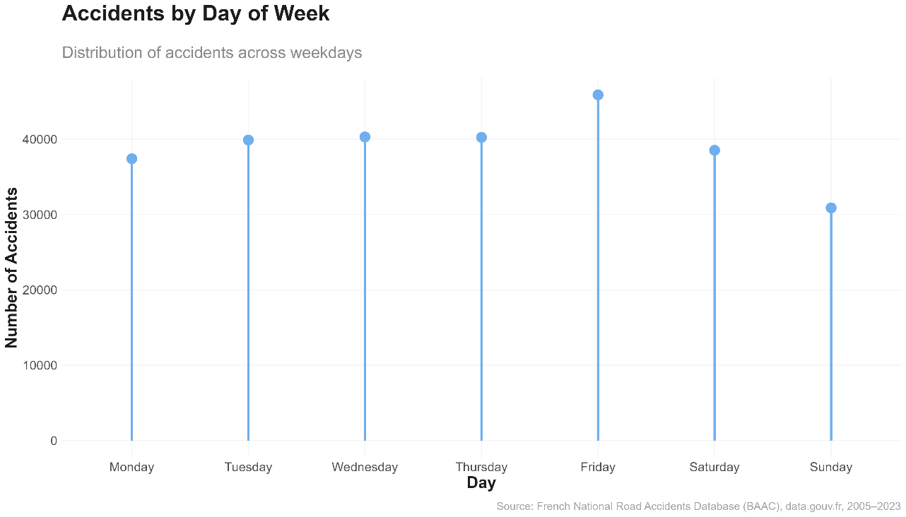

Figure 1 Accidents by Day of Week

Accident frequency also varies significantly by time of day. The data indicate a steady increase in accidents starting at 07:00, with a minor peak during the morning commute at 08:00. The most critical period occurs between 17:00 and 19:00, aligning with the evening rush hour, where accident counts reach their highest. After 20:00, frequency drops sharply, with the lowest counts recorded between 03:00 and 05:00, likely due to minimal traffic. A dashed trend line in the visualization confirms this pattern, emphasizing the heightened risk during evening commuting hours.

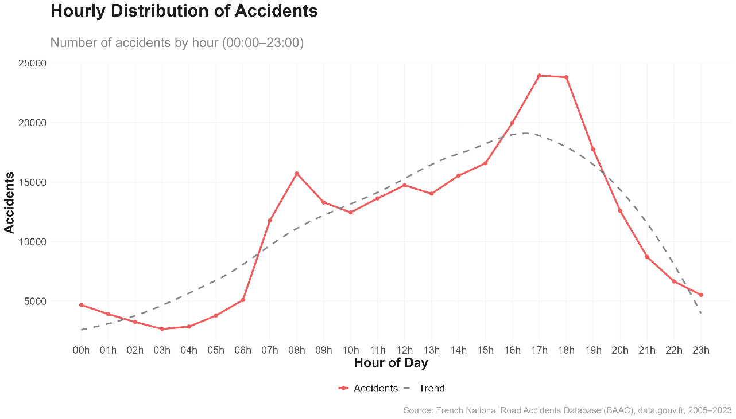

*Figure 2 Hourly Distribution of Accidents*

Seasonal trends further underscore predictable cycles, with accident peaks consistently occurring in May–June and October across the four-year period. October emerges as the most frequent danger point, likely driven by back-to-school and work commutes, worsening weather conditions, and reduced daylight. A gradual decline in accident volume over the study period is evident, as indicated by a loess trend line, reinforcing the need for seasonal safety campaigns, particularly before autumn.

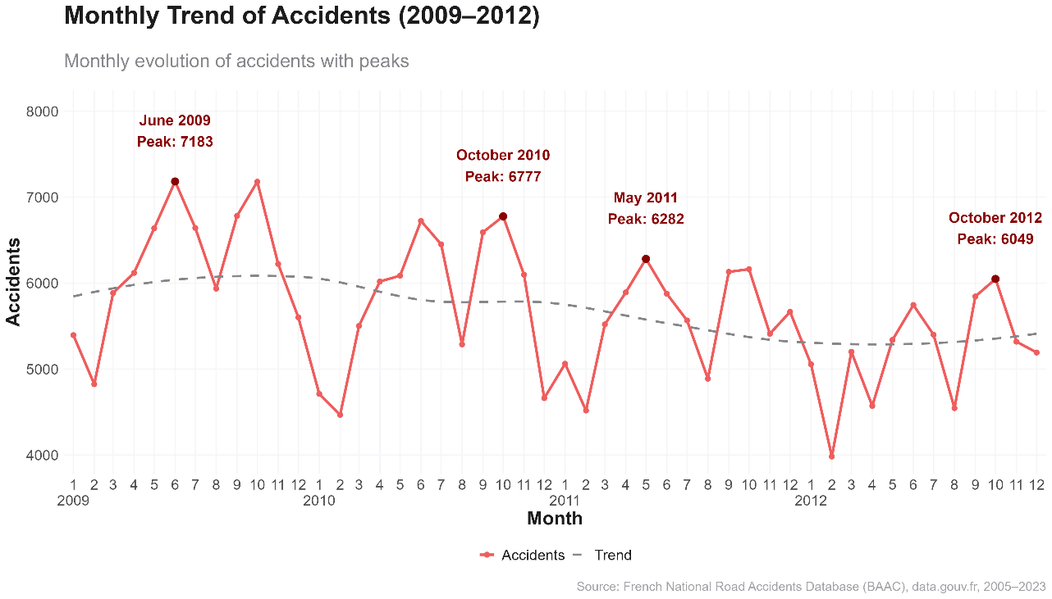

*Figure 3 Monthly Trend of Accidents*

A deeper analysis of accident density by day and time reveals that weekdays, particularly Fridays between 17:00 and 19:00, experience the highest concentration of accidents, driven by rush-hour traffic. Weekends, in contrast, show broader but less intense accident distributions, with moderate density extending into late-night and early-morning hours, possibly linked to nightlife activities.

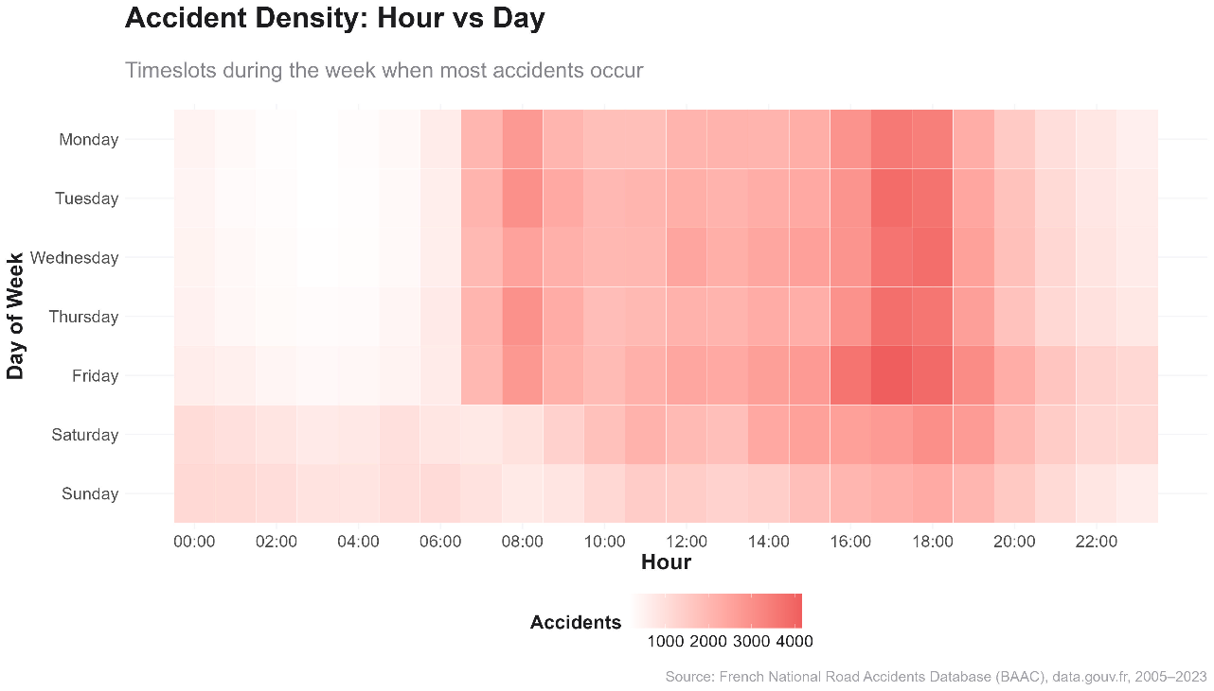

*Figure 4 Accident Density: Hour vs Day*

Public holidays also influence accident patterns, with Labour Day (672 incidents), Whit Monday (626 incidents), and Victory in Europe Day (620 incidents) recording the highest accident counts. These spring and early summer holidays likely see increased travel and leisure outings, contributing to higher road usage. In contrast, winter holidays like Christmas (322 incidents) and New Year (475 incidents) show lower counts, possibly due to reduced travel or enhanced enforcement. These findings highlight the need for targeted safety measures during high-risk holiday periods. 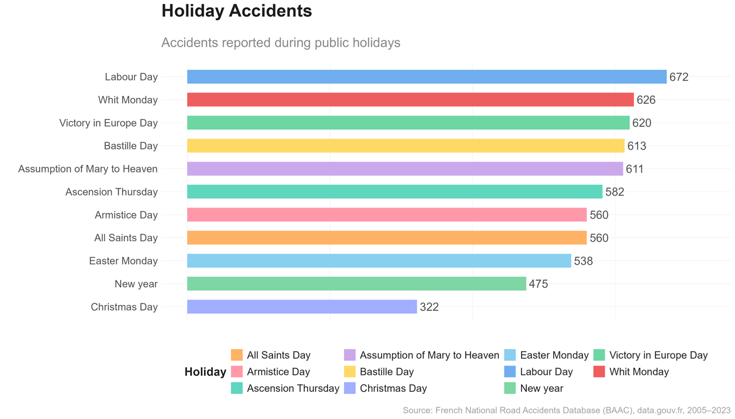

*Figure 5 Holiday Accidents*

# Geographic and Infrastructure Risk

#### Where Do Accidents Happen?

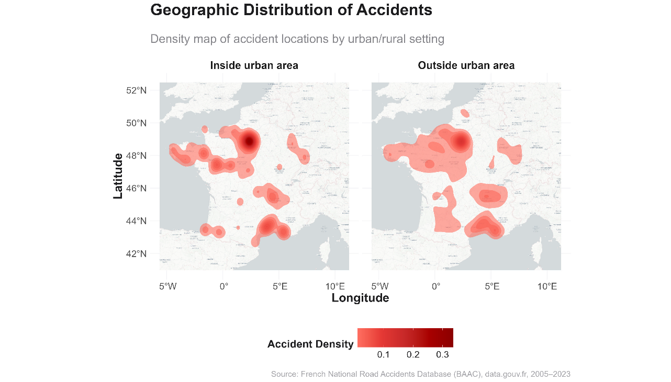Geographic and infrastructure factors play a significant role in road accident distribution. Urban areas, particularly Île-de-France (Paris region), Lyon, Marseille, and Bordeaux, exhibit high accident concentrations due to dense traffic, pedestrian activity, and urban congestion. In contrast, rural accidents are more dispersed, especially in central, eastern, and southern France, often occurring on departmental or national roads with higher speed limits and lower visibility. A 2D kernel density estimation (KDE) plot illustrates these patterns, with darker areas indicating higher accident density per unit area.

*Figure 6 Geographic Distribution of Accidents*

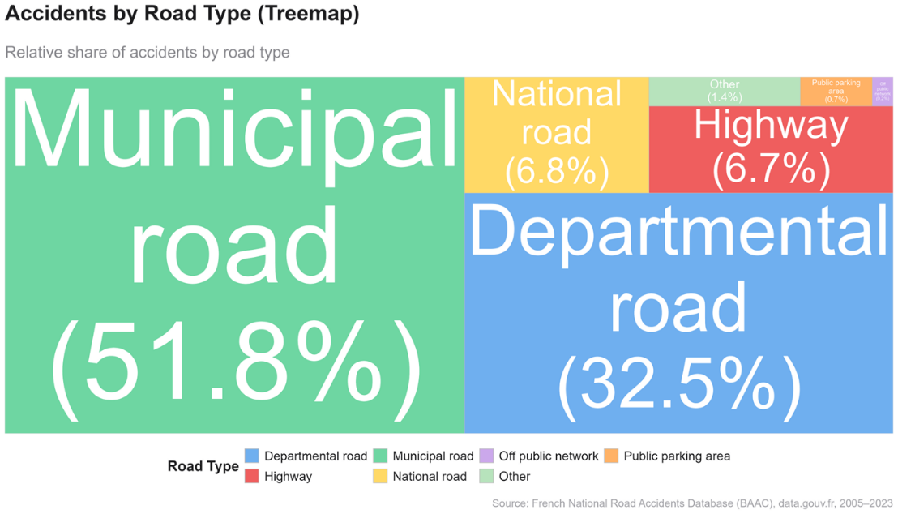Road type analysis reveals that municipal roads account for 51.8% of accidents, followed by departmental roads at 32.5%. National roads and highways, despite higher speeds, contribute only about 7% each, suggesting better design or stricter policing. Minor shares occur in parking lots and off-network locations, emphasizing the dominance of local and interregional roads in accident counts.

*Figure 7 Accidents by Road Type*

Infrastructure-specific risks highlight that over 240,000 accidents occurred on regular roads without special features. However, modified intersections are a significant risk point, with over 16,000 incidents, likely due to complex navigation, signaling issues, or blind spots. Interchange ramps (4,122 incidents) and bridges-overpasses (3,736 incidents) also pose notable risks due to merging complexities and speed variations. Pedestrian zones, tunnels, and railway crossings contribute smaller but non-negligible shares.

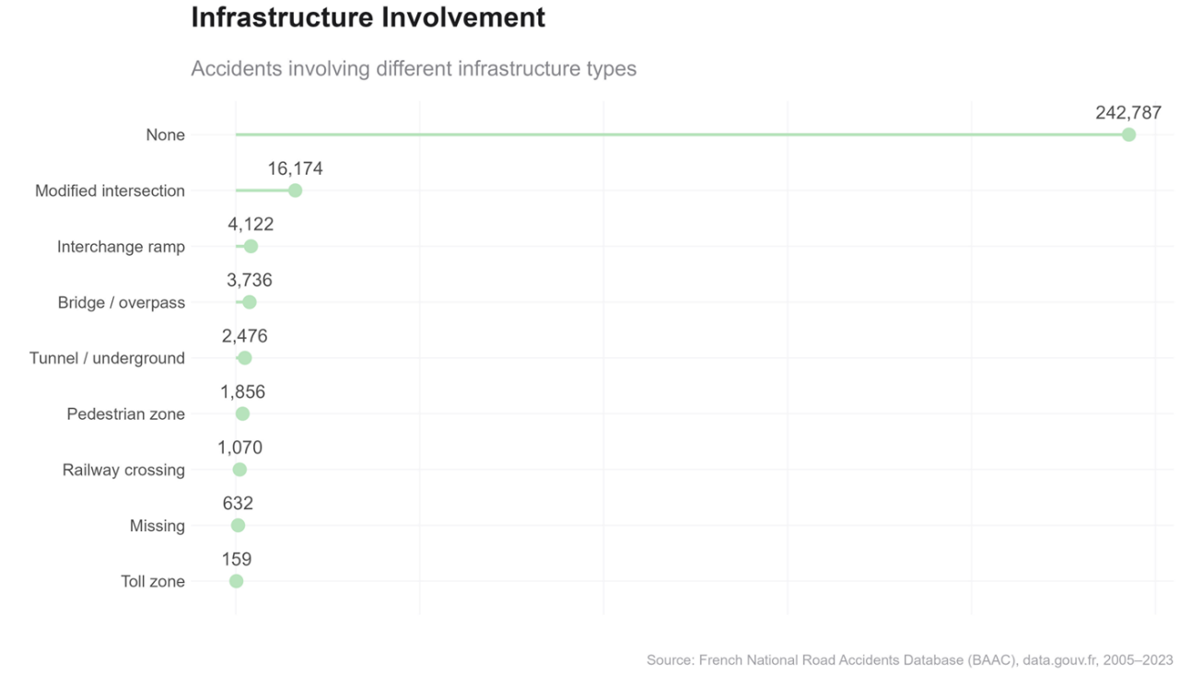

*Figure 8 Infrastructure Involvement*

Collision types further inform risk profiles. Side collisions (78,630) and rear-end crashes (30,561) dominate, often occurring at intersections, during lane changes, or in traffic congestion. Other collisions (89,820) represent scenarios outside common patterns. Head On collisions (25,785), though less frequent, tend to result in higher severity injuries, while multi-vehicle and chain collisions (8,000+) suggest issues like poor visibility or sudden braking. Nearly 30,000 cases involve no collision, such as rollovers or evasive maneuvers, yet still result in injuries.

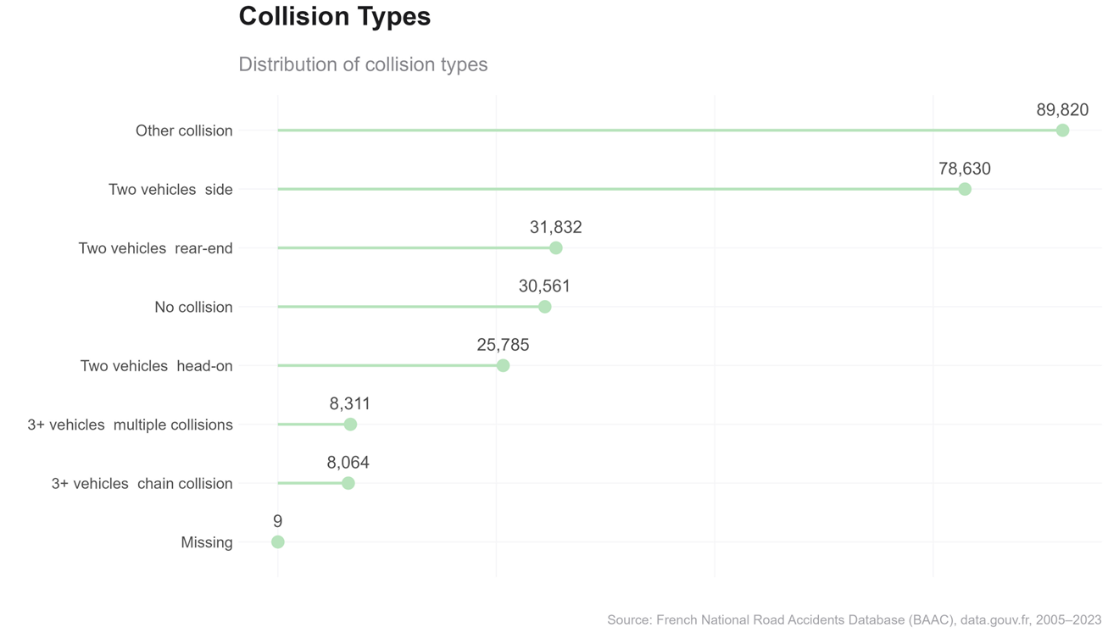

*Figure 9 Collision Types*

# Demographic Risk Profiles

#### Who is most involved in accidents?

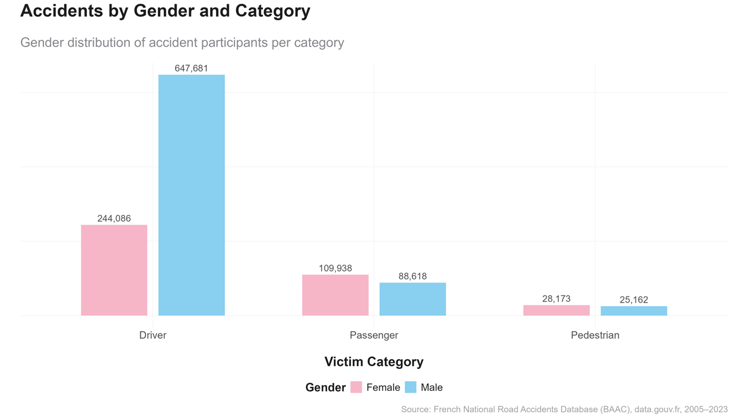Demographic analysis reveals distinct patterns in accident involvement by gender, age, and role. Among drivers, males (647,681) are nearly 2.7 times more involved than females (244,086), reflecting riskier driving behavior or higher vehicle usage. In contrast, females slightly outnumber males as passengers (109,938 vs. 88,618), while pedestrian involvement is nearly balanced (28,173 females vs. 25,162 males). These patterns suggest men drive more frequently, while women are more likely to occupy non-driving roles or use public transport.

*Figure 10 Accidents by Gender and Category*

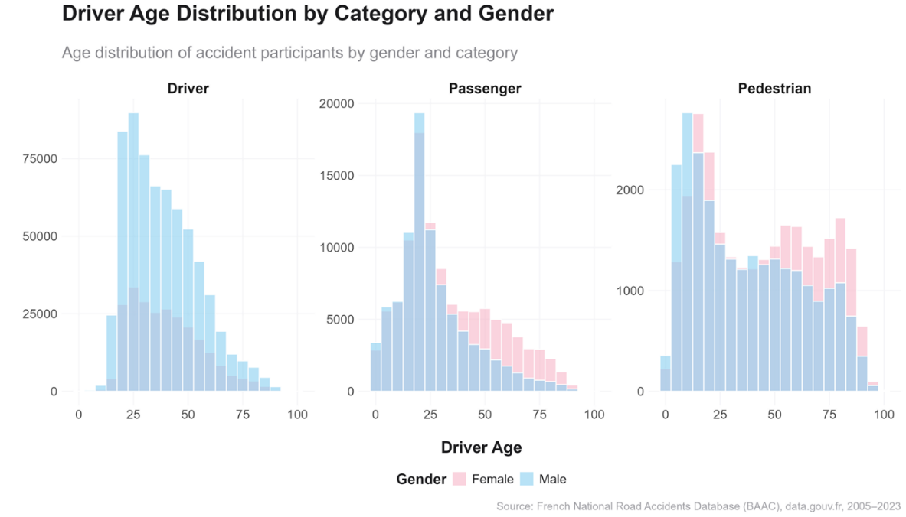Age and gender further refine risk profiles. Male drivers dominate across all ages, particularly under 40, while female involvement decreases with age, possibly due to licensing patterns. Passengers show more gender balance, with women slightly more represented in middle to older ages. Among pedestrians, elderly women (65–85+) are notably overrepresented, reflecting greater exposure and vulnerability.

*Figure 11 Driver Age Distribution by Category and Gender*

Young drivers (aged 20–35) are consistently overrepresented across all weekdays, with a median age around 30. Weekend accidents involve slightly younger profiles, likely due to leisure or nightlife activities.

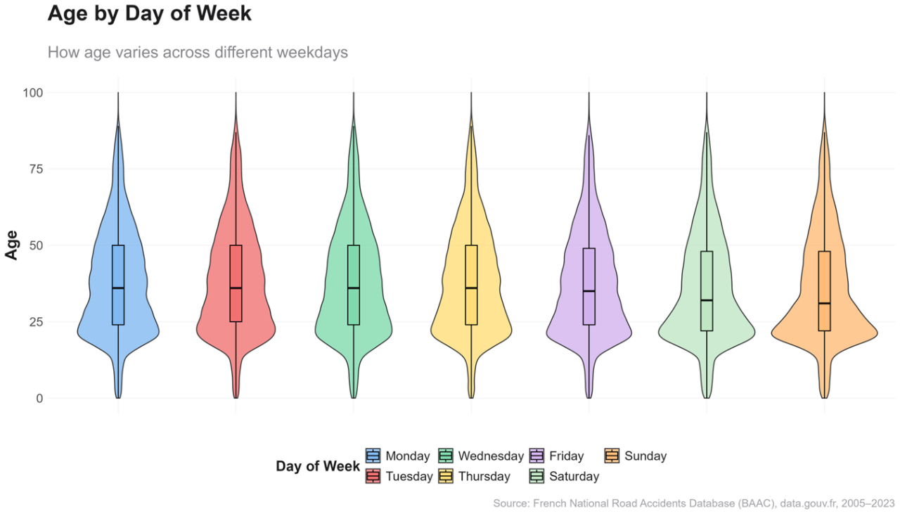

*Figure 12 Age by Day of Week*

Injury severity correlates strongly with age: younger drivers (20–35) experience more unharmed or minor injury outcomes, while hospitalizations and fatalities peak at 60+, reflecting physical fragility or slower reaction times. 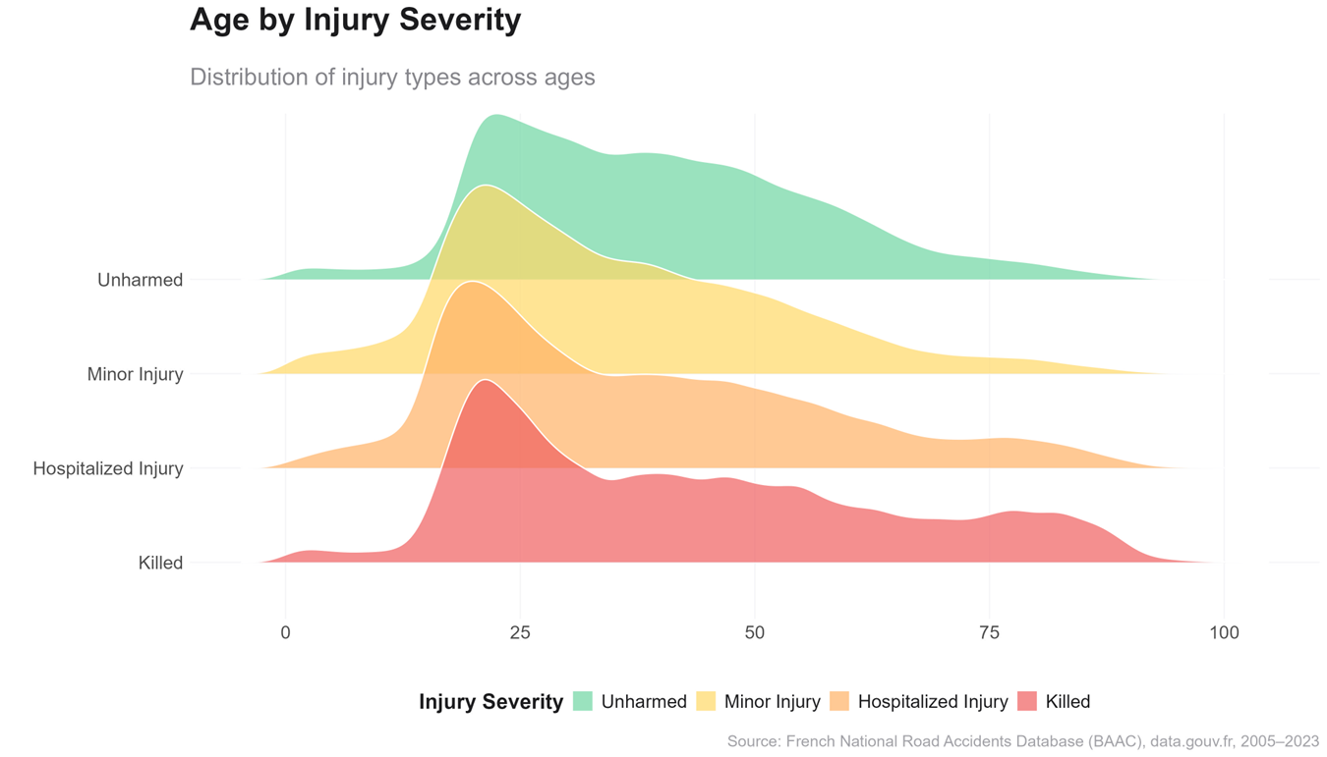

*Figure 13 Age by Injury Severity*

Figure 13 Age by Injury Severity

# Environmental Conditions

#### Do Weather, Light, and Road Surface Play a Role?

Environmental factors, while not the primary drivers of accidents, contribute significantly to risk under specific conditions. Approximately 81% of accidents occur in normal weather, underscoring human behavior as the dominant factor. However, light rain (10%), overcast conditions (3%), and heavy rain (2%) account for a notable share, with severe weather (snow, hail, fog, blinding sun) contributing about 5%.

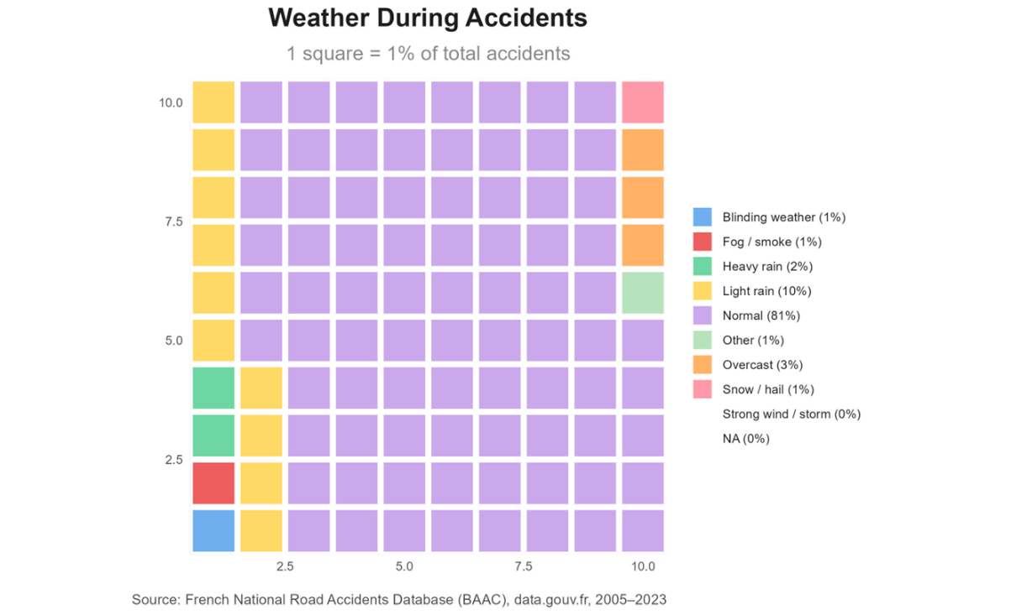

*Figure 14 Weather During Accidents*

Road surface conditions further highlight behavioral dominance, with over 213,000 accidents occurring on dry roads. Wet surfaces (44,574 cases, 17%) and icy roads (over 2,000 cases) increase risk, while snowy, greasy, or flooded roads, though rare, pose significant hazards. These findings emphasize the need for winter readiness campaigns. 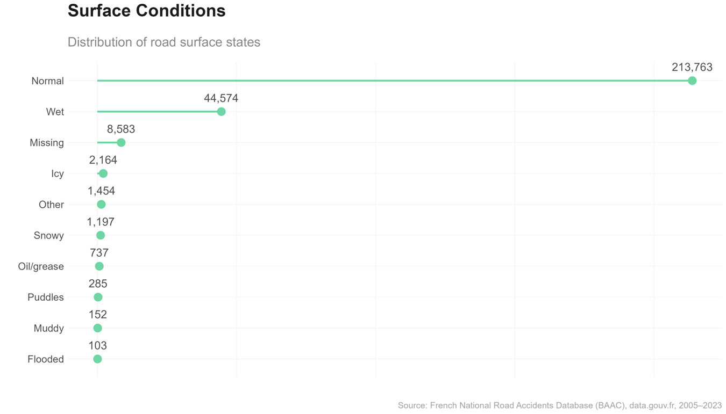

Figure 15 Surface Conditions

*Figure 15 Surface Conditions*

Lighting conditions also influence accident risk. Daylight accounts for 188,099 accidents, driven by high traffic volume. However, poorly lit or unlit night conditions (over 20,000 cases) show elevated risks, particularly in rural areas or with faulty urban lighting. Street lighting mitigates some risk, with 45,848 night accidents under lit conditions compared to 20,825 in unlit settings.

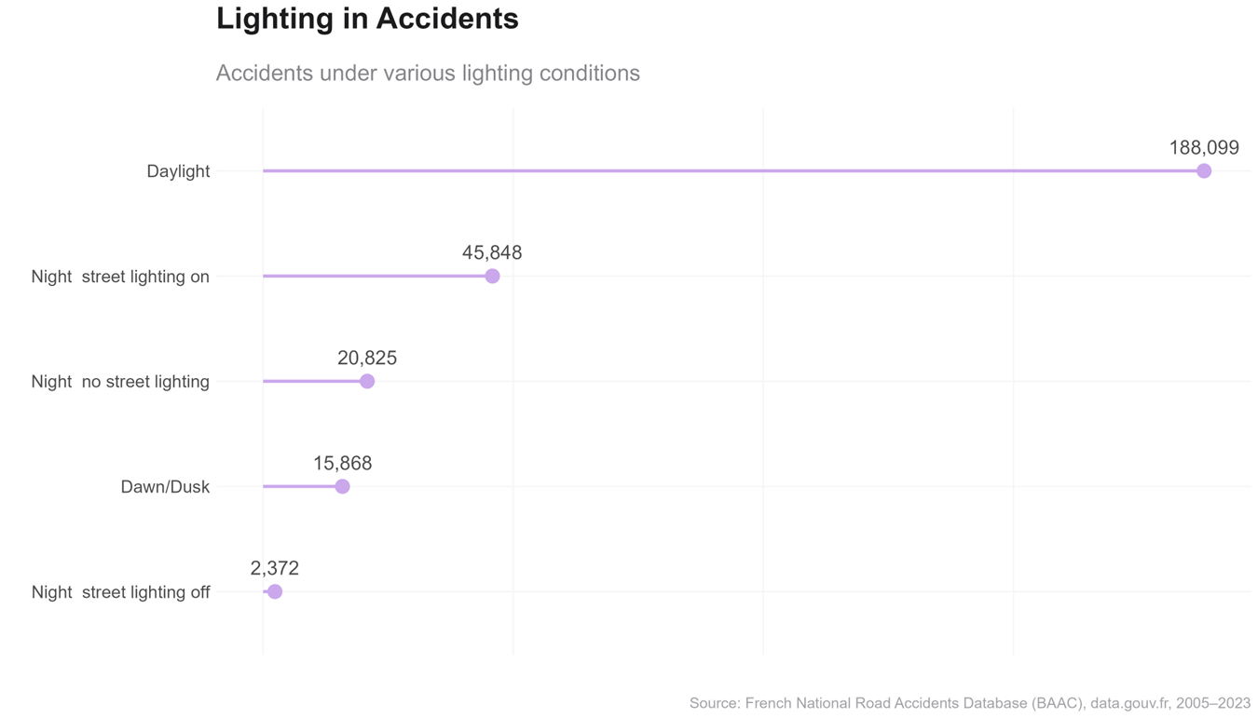

*Figure 16 Lighting in Accidents*

# Injury Severity and Health Outcomes

#### How Severe Are the Consequences?

The human toll of road accidents is substantial, with 503,071 participants unharmed, 404,393 sustaining minor injuries, 210,558 hospitalized, and 26,665 fatalities. These figures highlight the effectiveness of safety features like seatbelts and airbags in reducing harm, but the high number of hospitalizations and deaths underscores the need for continued intervention. 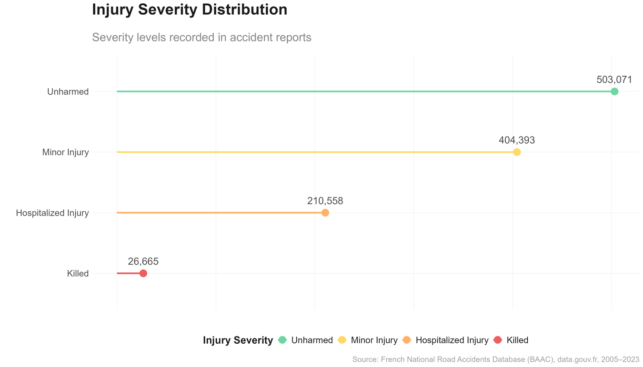

*Figure 17 Injury Severity Distribution*

Lighting conditions significantly affect injury severity. Daylight accidents (805,161 total) have a fatality rate of approximately 1.97 per 1,000 and a hospitalization rate of 17.78%. In contrast, night accidents without street lighting (88,031 incidents) have a fatality rate of 70.36 per 1,000 and a hospitalization rate of 28.32%, making them approximately 35 times deadlier than daytime accidents. Street lighting reduces severity but does not eliminate risk.

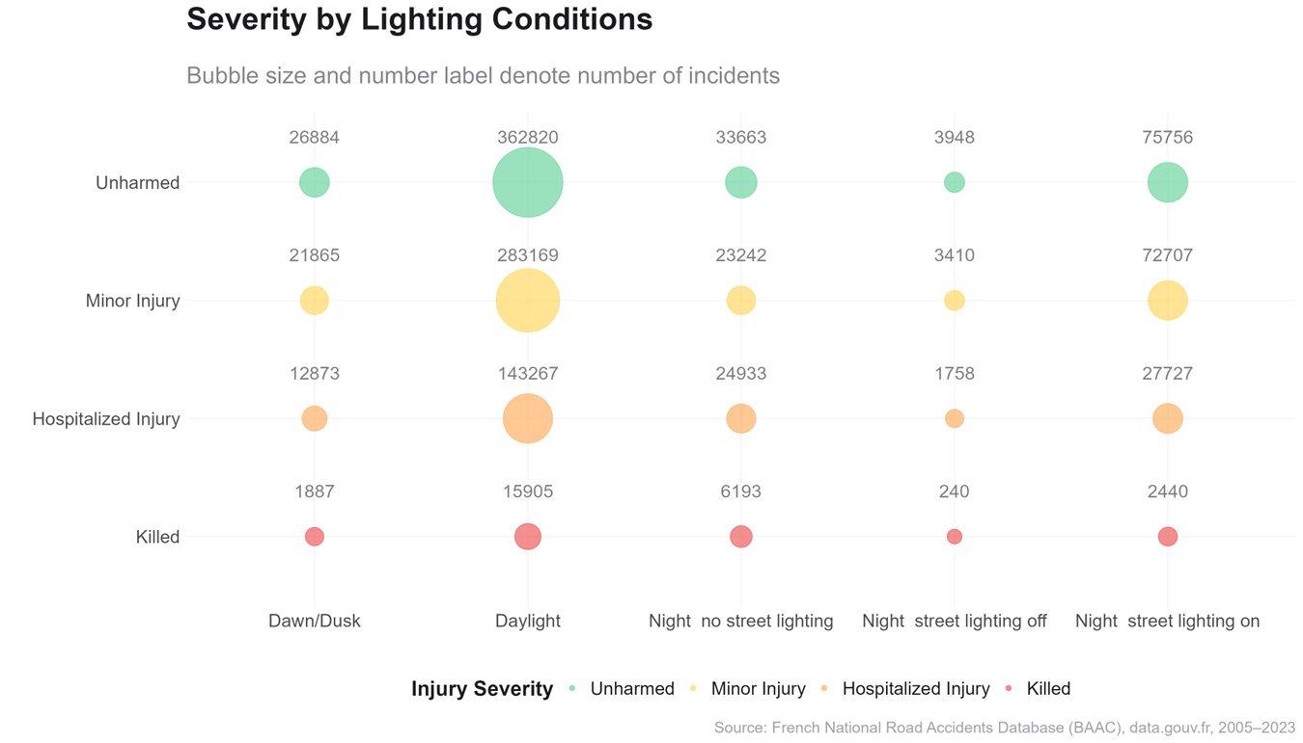

*Figure 18 Severity by Lighting Conditions*

Hazardous road surfaces, such as wet (183,000 accidents, 25.67 deaths per 1,000), icy (15,500 cases, over 20 deaths per 1,000), and flooded roads (427 cases, 65.6 deaths per 1,000), show significantly higher fatality and hospitalization ratios compared to normal surfaces. These conditions, though less frequent, demand targeted safety measures.

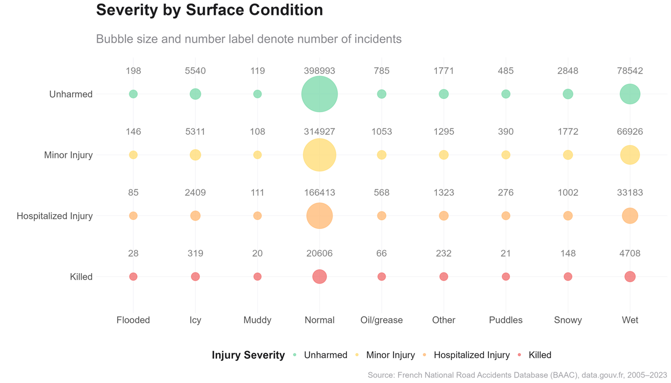

*Figure 19 Severity by Surface Condition*

Figure 19 Severity by Surface Conditions

Vehicle type also influences outcomes. Motorcycles and scooters exhibit the highest per capita severity, followed by trucks. Cars show more unharmed outcomes due to structural safety features, while buses and trams record the lowest severity, likely due to low speeds and professional drivers.

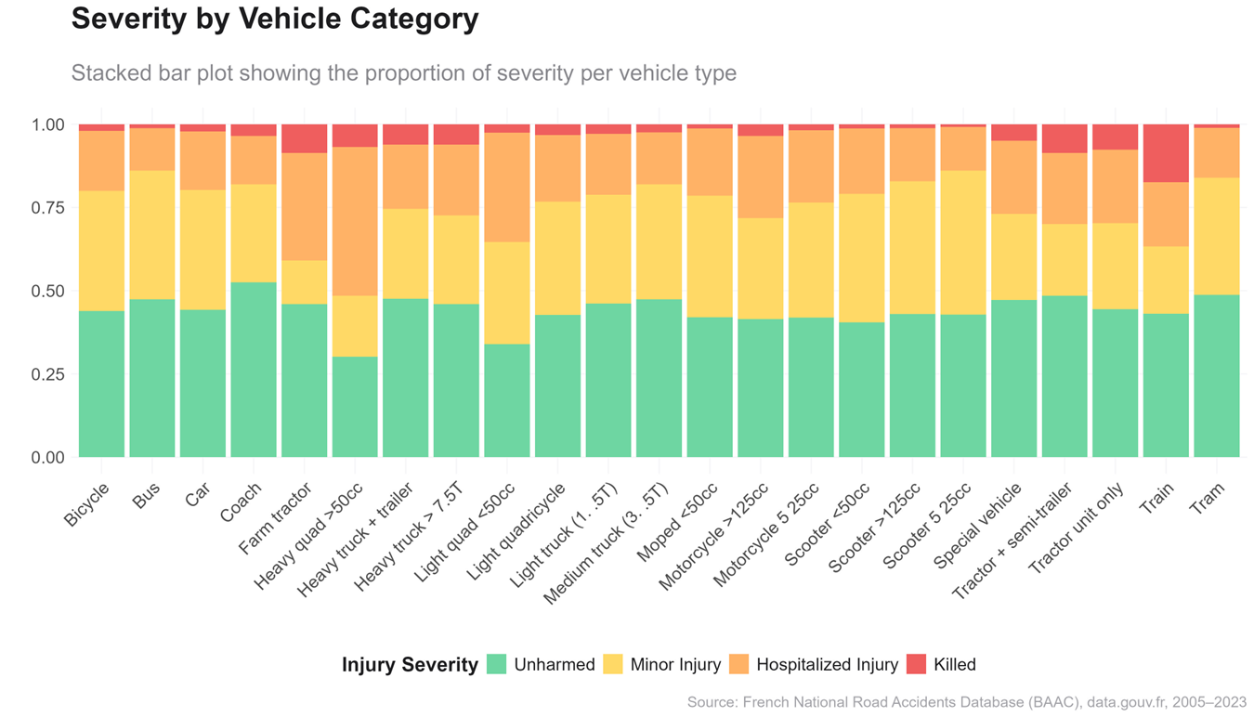

*Figure 20 Severity by Vehicle Category*

Safety equipment usage is a critical determinant of injury severity. Participants using seatbelts or helmets report nearly 45% unharmed outcomes, with low fatality and hospitalization rates. Non-usage is linked to significantly higher severe and fatal injuries, reinforcing the importance of safety equipment. Unknown usage data highlights a need for improved data collection.

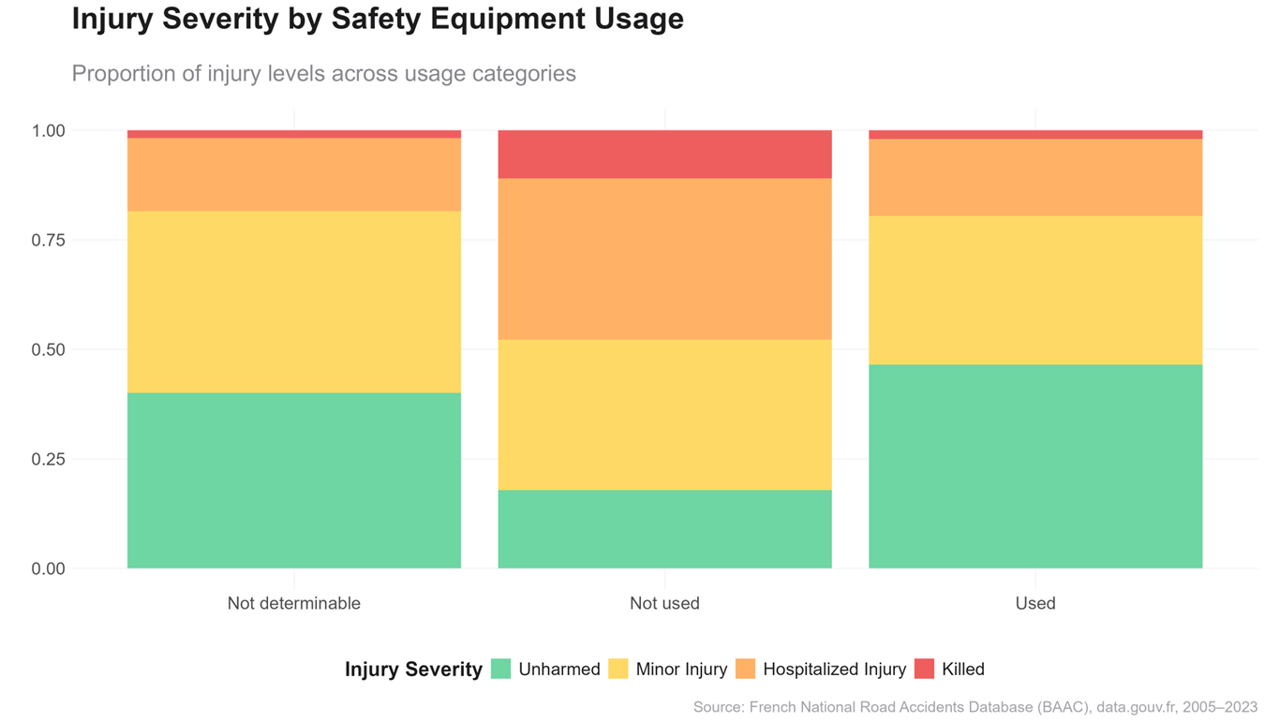

*Figure 21 Ingury Severity by Safety Equipment*

# Behavior and Exposure

#### Why, How, and With What Do People Travel?

Travel purpose significantly influences accident volume, with leisure-related trips leading at 428,110 cases, nearly 3.5 times higher than work commutes (120,307) or on-the-job driving (81,000+). Other purposes, such as errands (52,000) and school-related trips (20,000+), contribute smaller shares. Nearly 300,000 cases with unknown travel reasons indicate a data quality challenge. Leisure travels dominance aligns with weekend and nighttime patterns, reflecting longer routes and higher risk exposure.

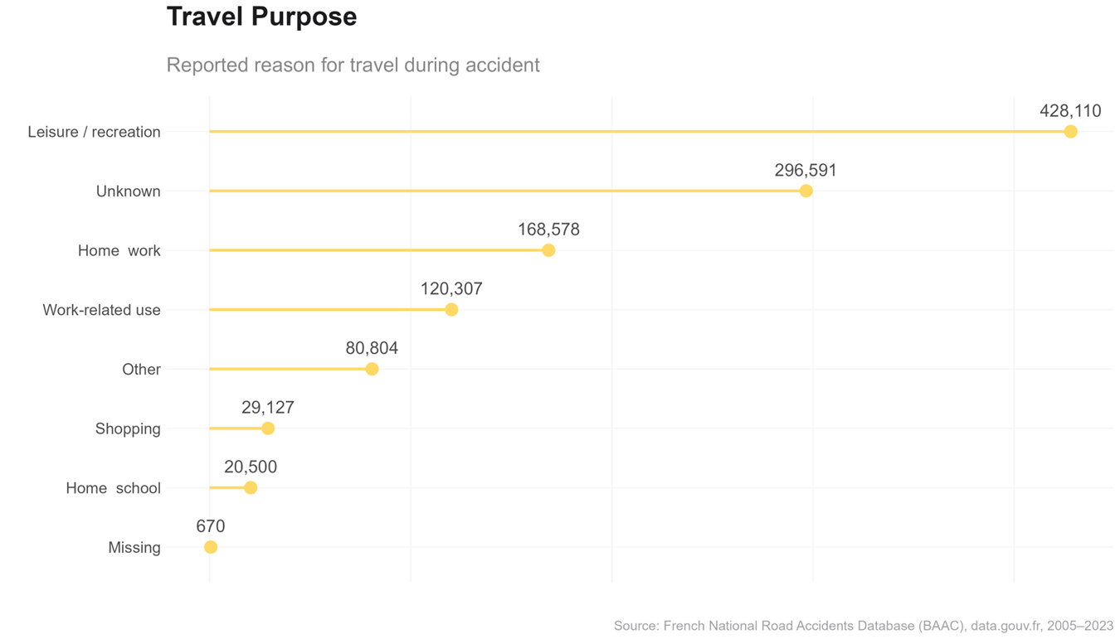

*Figure 22 Travel Purpose*

Safety equipment usage data shows over 900,000 participants reported using safety gear, while 31,000 did not, and 180,000 cases were undetermined. This underscores the need for stricter enforcement and better data collection.

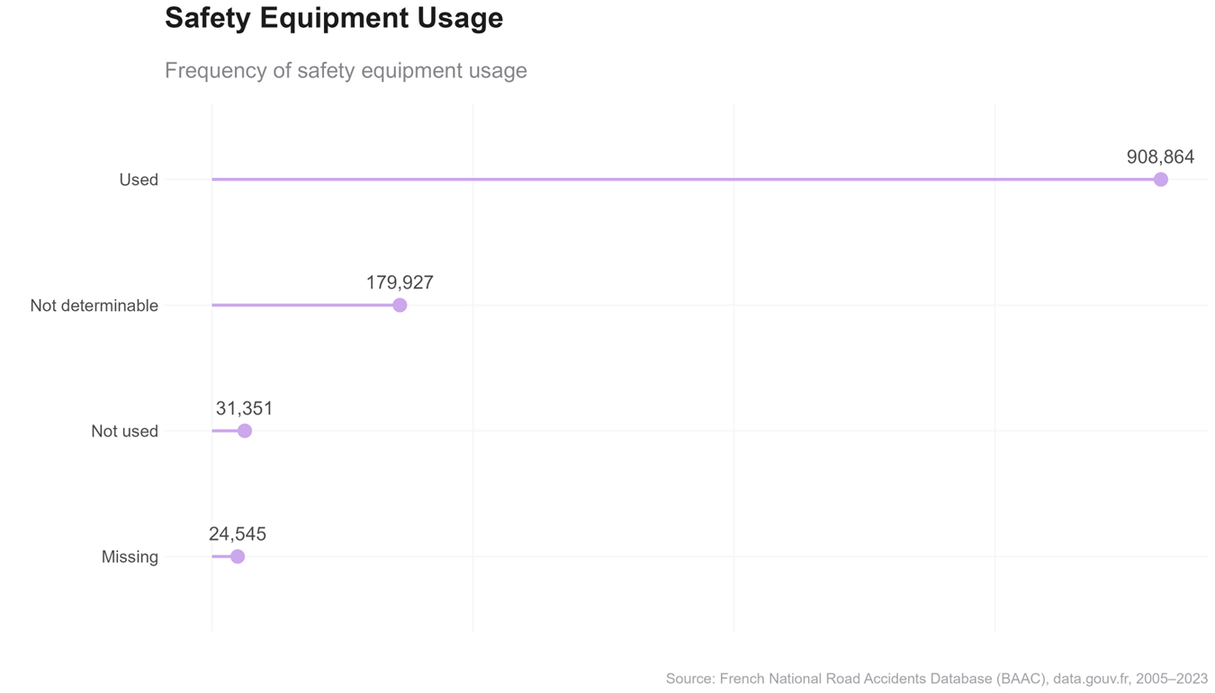

*Figure 23 Safety Equipment Usage*

Vehicle type analysis confirms cars dominance (214,204 involved), followed by scooters, mopeds, and motorcycles, which exhibit high vulnerability. Light and heavy trucks, bicycles, buses, and agricultural vehicles contribute smaller but notable shares. 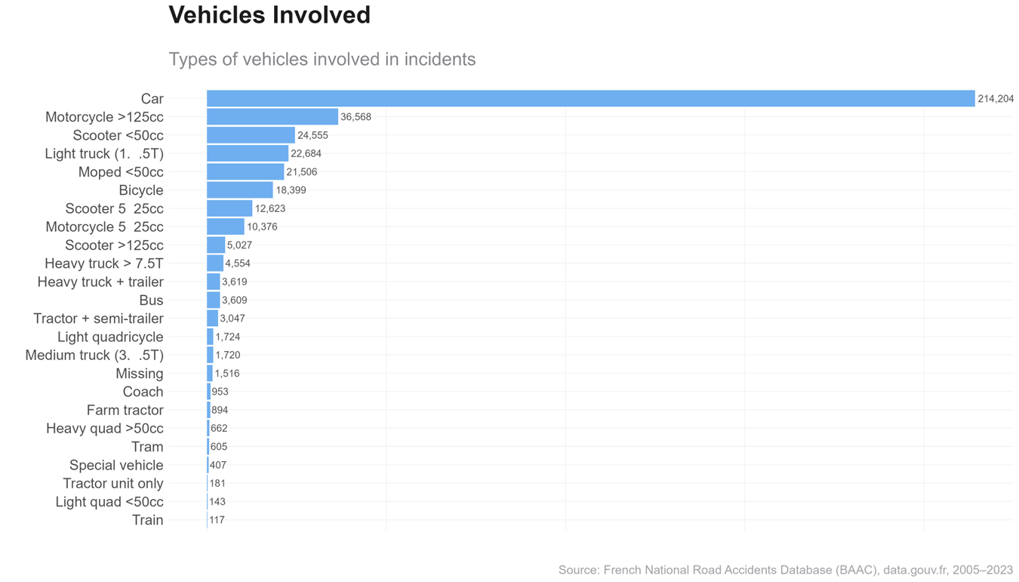

# Tableau Dashboard: Interactive Approach

*Figure 24 Vehicles involved*

### Dashboard Summary: "France on the Road: A Nation in Motion"

This interactive Tableau dashboard provides a comprehensive analysis of road traffic accidents in France between **2009 and 2012**, utilizing official government datasets. It visualizes accident trends, conditions, and demographics to uncover critical insights for transportation planning and public safety policies.

### Key Components and Their Purpose:

1. **Map of Road Accidents**  
   A geo-spatial visualization of accident locations across France (for entries with available coordinates between 2009 and 2012). It allows identification of regional hotspots and geographical clustering patterns of incidents.
2. **“Vehicle Types”, “Weather Conditions” and “Surface Conditions” Panels**  
   These visualizations summarize the frequency of different environmental conditions at the time of accidents. For example, over **81%** of accidents occurred under normal weather conditions, while **10.1%** were under light rain weather. Road surface conditions similarly highlight the dominance of normal roads but draw attention to critical percentages under bad conditions, which may demand policy interventions.
3. **Quarterly and Monthly Trends**  
   The temporal line and bar plots track accident counts across months and quarters, revealing seasonal fluctuations. Peaks are evident in spring months (March-May), hinting at increased travel or risk during these periods.
4. **Gender Analysis**  
   Comparative bar plots break down the types of vehicles involved in accidents by **driver and gender**. For example, male drivers are involved in significantly more incidents, especially with cars and motorcycles. This enables gender-targeted safety campaigns and education.
5. **Age and Injury Severity Distributions**  
   Boxplots show the age spread by gender, and injury charts display the severity distribution (unharmed, minor injury, hospitalized, or killed), combined with protection (seatbelt, helmet, etc.). This highlights the importance of protective gear and the higher vulnerability of certain age groups.
6. **Travel Purpose Treemap**  
   A treemap of travel motives reveals that a large proportion of accidents happen during **leisure-recreational trips** and **home-related travel**, suggesting peak risk times and behaviors.
7. 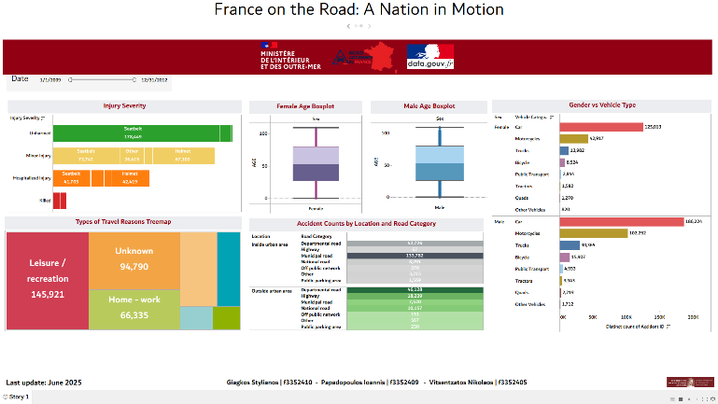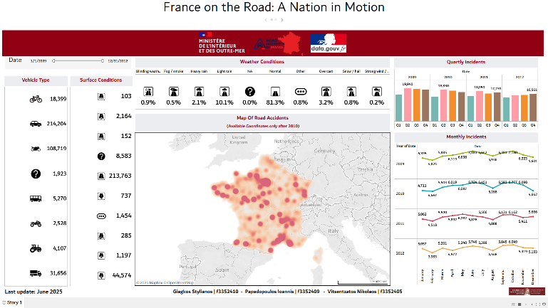**Road Category vs. Location Matrix**  
   A matrix view compares urban vs. non-urban accident distributions across road types (highways, departmental, municipal). Most incidents occur **inside urban areas** on **national and municipal roads**, emphasizing the need for better city traffic management.

*Figure 25 Tableau Overview*

# Conclusions and Policy Recommendations

#### Summary of Findings

Road accidents in France from 2009 to 2012 exhibit predictable temporal and spatial patterns. Fridays, particularly between 17:00 and 19:00, and the month of October consistently show the highest accident counts. Urban areas, especially major cities, concentrate incidents, while rural and departmental roads pose significant risks due to higher speeds and lower visibility. Environmental factors, while influential, are secondary to human behavior, with over 80% of accidents occurring in good weather, daylight, and on dry roads. Young male drivers (aged 20–35) dominate accident involvement, while older individuals face more severe outcomes. Leisure-related travel, particularly during holidays and weekends, accounts for the highest accident volumes, and non-usage of safety equipment significantly increases injury severity.

#### Policy Recommendations

To address these findings, the following evidence-based recommendations are proposed:

1. **Demographics and Driver Behavior**: Expand targeted education for young drivers, emphasizing emotional control, fatigue management, and risk awareness. Implement senior driver health screenings to reduce fatality risks in aging populations.
2. **Time-Based Enforcement and Awareness**: Increase traffic enforcement, including speed checks and alcohol tests, during Friday evenings and holiday weekends. Launch seasonal safety campaigns before high-risk periods like September, October, and spring holidays.
3. **Urban Planning and Infrastructure**: Enhance street lighting in rural areas and high-risk urban zones to reduce nighttime accident severity. Improve pedestrian and cyclist safety on municipal roads through better signage and infrastructure design.
4. **Vehicle and Equipment Regulation**: Enforce stricter penalties for non-compliance with helmet and seatbelt usage. Promote Advanced Driver-Assistance Systems (ADAS) in motorcycles and trucks to mitigate severe outcomes.
5. **Leveraging Data for Policy**: Improve accident report forms to capture behavioral and safety equipment data more accurately. Fund regional traffic safety observatories to monitor and respond to emerging trends.

These recommendations aim to create a safer and smarter road network in France by addressing temporal, geographic, demographic, and behavioral risk factors identified in this analysis.

# Appendix & Acknowledgments

|  |  |
| --- | --- |
| Appendix of Contributions | |
| Stylianos Giagkos (f3352410) | Storytelling - Rplots (Animated 1-5 & Static 5-12) - Tableau Dashboards Presentation - Presentation - Report |
| Vitzentzatos Nikolaos (f3352405) | Storytelling - Rplots (Static 12-24) - Presentation - Tableau Dashboards - Presentation - Report |
| Papadopoulos Ioannis (f3352409) | Storytelling - Tableau Dashboards - Report |

The authors thank the professors of the MSc Data Science program for their guidance and the French Ministry of the Interior for providing access to the BAAC dataset, enabling this comprehensive analysis.

********